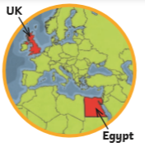

**Ancient Egypt Knowledge Organiser Year 5 Autumn**

|  |  |
| --- | --- |
| Key Vocabulary | |
| BC | Used to show that a date is before the year 0. This is counted backwards, so 200 BC is before 100 BC. |
| AD | Used to show that a date is after the year 0. This is counted forwards, so AD 100 is before AD 200. |
| Artefact | An artefact is a man-made object, such as pieces of art or tools, that is of particular historical interest. |
| Hieroglyphs | A system of writing that used pictures and symbols instead of letters. |
| Agriculture | Agriculture is another word for farming. It includes both growing and harvesting crops and raising animals. |
| Societal Hierarchy | A system in which member of society were ranked according to their social status or authority. |
| Pharaoh | A ruler of Ancient Egypt. |
| Empire | Empire is a term used to describe a group of territories ruled by one single ruler or state |
| Legacy | Something that has been left behind. Impacts or effects from a time period. |

|  |
| --- |
| When and where? |
| Ancient Egypt was a civilization in North Africa concentrated along the Nile River. The period started with the reign of Egypt's first king, Narmer, in approximately 3100 BCE and ended with the death of Cleopatra VII in 30 BCE. |

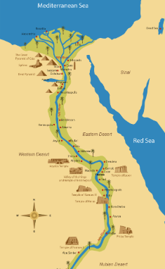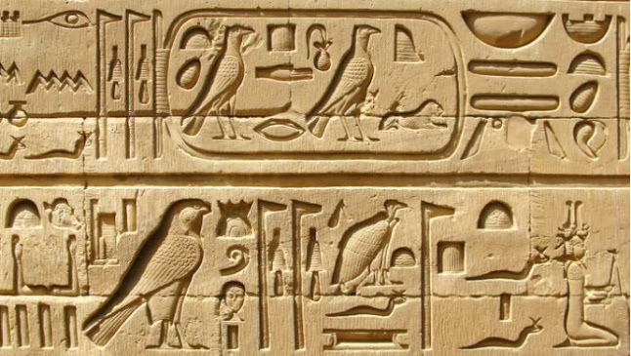

|  |
| --- |
| The Nile |
| The river Nile was essential to life in ancient Egypt. Every year, it flooded, leaving behind a black silt that enriched the soil for growing crops. The river was also used to irrigate fields in other areas.  Most people lived along and around the Nile. This is still true in Egypt today. The river was used for water, fishing and trade. Mud from the river was used for bricks and papyrus plants were used to make paper. |

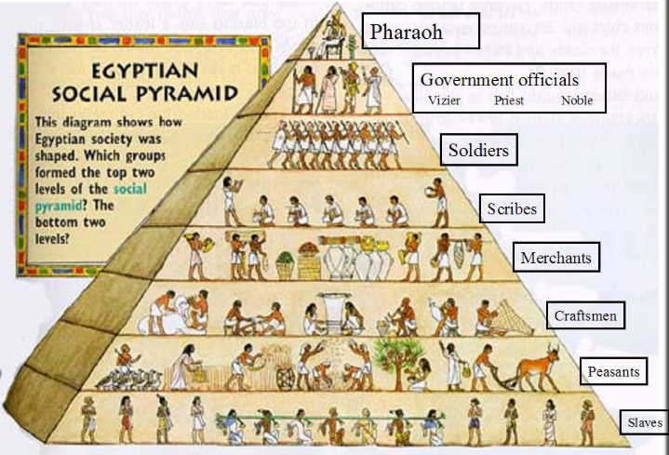

|  |
| --- |
| Pharaohs |
| Pharaohs were the king or queen of Egypt. Most pharaohs were men but some well-known pharaohs such as Nefertiti and Cleopatra were women. A pharaoh was the most important and powerful person in the kingdom. They were the head of the government and the high priest of every temple. The people of Egypt considered the pharaoh to be half-man, half-god. Without doubt, the most famous pharaoh was Tutankhamun. He reigned from 1337 – 1328BC and his tomb was discovered by a team of British archaeologists in 1922, nearly 3000 years after his death. |

|  |
| --- |
| Canopic Jars |
| It was very important to Ancient Egyptian religious beliefs that the human body was preserved. Canopic jars were used to hold the internal remains after mummification. The lids of the jars were decorated with the four heads of Horus, the Egyptian God of the sky. |

