Y3 Autumn Term
Industrial Revolution
The following activities are optional homework activities that you could do to further your learning in school. If you complete one of them, we would love for you to share it with the rest of your class, either as a photo or by bringing the finished product in.
Create a fact file about Isambard Kingdon Brunel.  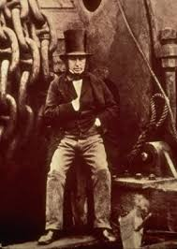 | Find a torch and shine it against a wall. What shadow shapes can you make using your hands and fingers? Can you put toys in front of the torch to see their shadow shapes? If you move the toy nearer the torch, does it make the shadow bigger or smaller? Now, move it away. What happens?  Can you explain why it happens?   | Make a drawing, painting, or collage of a Watson Fothergill building. There are examples of his architecture in Mansfield. He designed the swan pub and the building near Watermeadows which is now a restaurant.  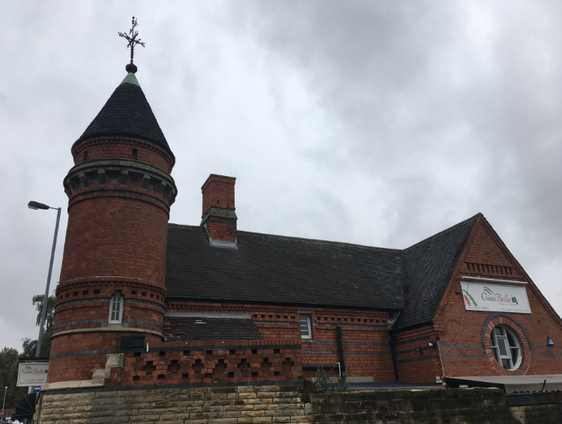
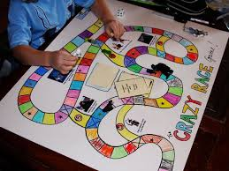  Design and make a Mining-themed board game. It could have question cards or penalties like missing a go if you land on certain squares. | Find out how pit ponies were used in Victorian times down the mine. Show your findings as a poster or report.  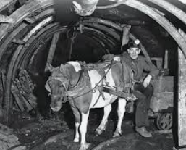 | Make a bridge at home which is 20cm long and can support a heavy book.  