Y5 Autumn Term
Ancient Egypt
The following activities are optional homework activities that you could do to further your learning in school. If you complete one of them, we would love for you to share what you have done with your teacher and class.
Write a secret message in hieroglyphics and present it in the style of a cartouche.  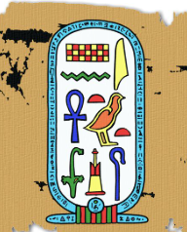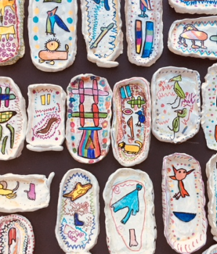 | Research a famous Ancient Egyptian pharaoh and create a fact page about them. Present this however you like.  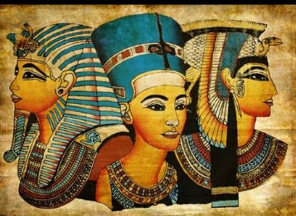 | Write your own Ancient Egyptian adventure story. This could be about a made up character, a god or goddess or about a famous Ancient Egyptian.  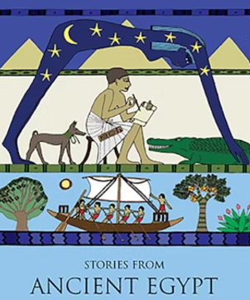
Design and make a model of an Ancient Egyptian Sarcophagus.  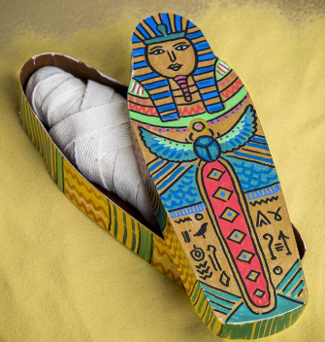 | In Ancient Egyptian times, they used to mummify the dead by wrapping and preserving the bodies. You can have a go at mummifying an orange at home by following the instructions on the website below! Take some photos of what happens to the orange.  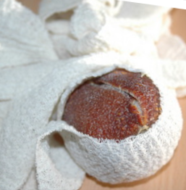  https://www.yac-uk.org/activity/mummify-an-orange | Research the Ancient Egyptians’ diet and make something that they would have eaten.  