Y5 Spring Term
Our Wonderful World
The following activities are optional homework activities that you could do to further your learning in school. If you complete one of them, we would love for you to share what you have done with your teacher and class.
Make a model of the solar system showing the order of the planets in relation to the sun.  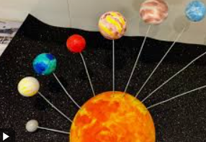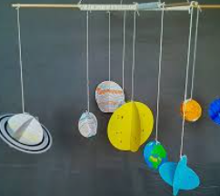 | Write a fact file about a famous astronaut.  You could choose Tim Peake, Neil Armstrong or anybody else you would like to research.  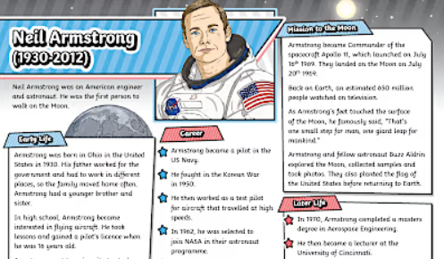 | Write an acrostic poem about a type of weather.  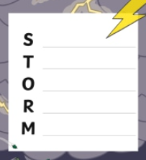
Create a piece of space themed art work using a media of your choice (paint, pencils, pen).  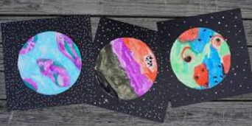  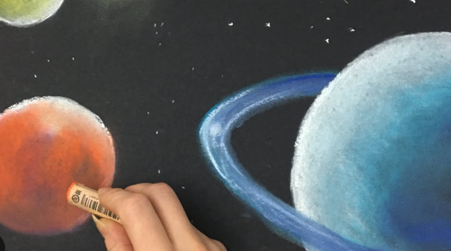 | Research and create a leaflet/booklet about extreme weather. You can choose just one type of extreme weather for this, or you can do this about different weathers.  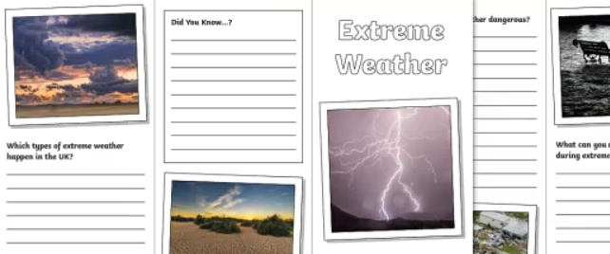 | Create a model of a volcano.  https://www.jpl.nasa.gov/edu/resources/  project/  make-a-volcano/  