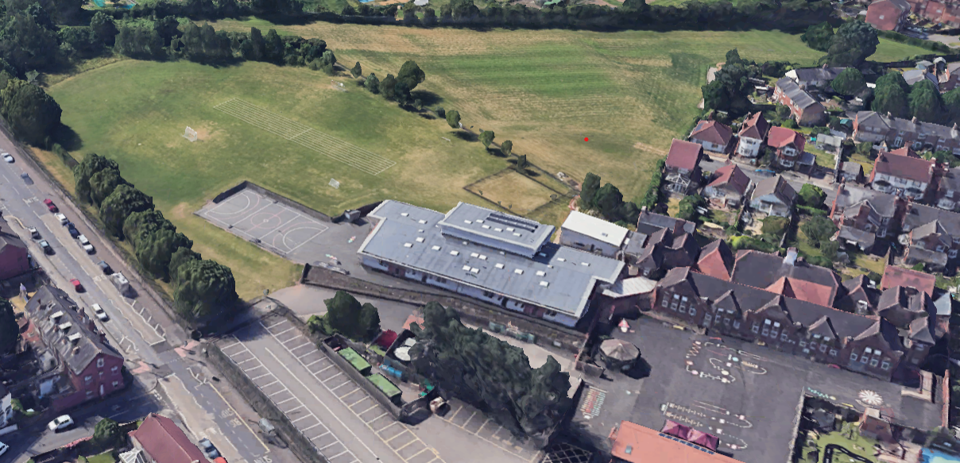
Zone 2 – Wheels
Scooters Push chairs
Skateboards
Bikes
Ride Ons

Zone 7 – Creative
Sand & Water Play
Lego & Building Blocks
Arts & crafts

Zone 5 – Construction
Plastic Crates
Cardboard Boxes & Sheets
Tyres & Pallets
Coil Reels
Digging Area
Zone 4 -Sports
Tennis & Basketball
Hoops & stilts
Football & Badminton
Space hoppers
Balance boards

Zone 3 – Quiet/Cosy Area
Books & Games
Cushions & Blankets

Zone 1 - Small World & Role Play
Dolls
Cars
Dinosaurs
Animals
Kitchens
Dress up

Zone 6 - Mud Kitchen
Pots & Pans
Cookery
Trucks & Cars
Kitchens & Sinks
Tables & Chairs

